Office hours:
Michelle.Jurkovich@umb.edu
Professor Michelle Jurkovich
Class Time:
Room:

The Politics of Food Security

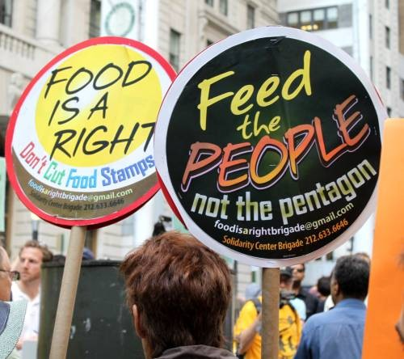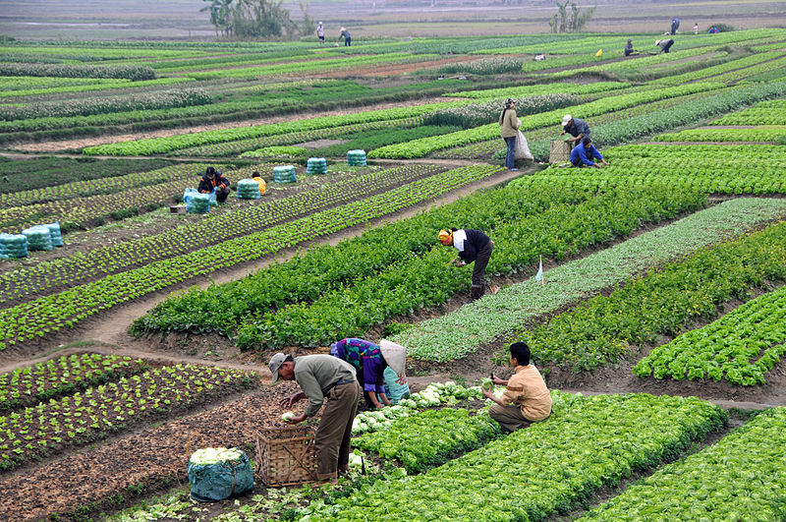

Course Description
There is enough food on the planet to feed everyone, and yet currently approximately 800 million people go hungry. Why is this the case? This course explores the politics of international food security, dividing the semester into four sections to examine food through the lens of development, human rights, governance, and security concerns.

Our weekly discussions will focus on questions such as: Who governs food security? Why and how have states responded to global hunger? What are the key ethical challenges facing this field? What does domestic and international activism look like in this issue area? Is food security a development problem or a human rights problem? What happens when these approaches clash? Does food insecurity encourage domestic instability? Our readings for this course will highlight key debates around food security, including contemporary debates on questions of GMOs and the “buy local” movement as these affect broader human rights and development goals.

Course Goals

The goal of this course is to:
- Enable students to think (and write) critically on the topic of international food security
- Provide students with on overview of historical and contemporary debates in the issue area
- Encourage students to think analytically about how the issue of food security can affect broader theoretical conversations (especially in the field of international relations) and understand and engage with ethical challenges in this field
- Enable students to think clearly about complex debates in food security and engage in critical debate on these topics in a concise and constructive way.

Course Outcomes

At the end of the semester, students should be able to:
- Understand the contours of key international food security debates and think critically about them
- Understand where to look (i.e. identify primary and secondary sources) when investigating questions of food security
- Conduct research and write a research paper with analytic depth OR prepare and execute a successful research protocol and project
- Convey complex ideas in a clear and concise way and engage in critical debate

Class Policies

Special accommodations: Section 504 of the Americans with Disabilities Act of 1990 offers guidelines for curriculum modifications and adaptations for students with documented disabilities. If applicable, students may obtain adaptation recommendations from the Ross Center for Disability Services, M-1-401, (617-287-7430). The student must present these recommendations and discuss them with each professor within a reasonable period, preferably by the end of Drop/Add period.

Audio and Video Recording: Recording lectures (audio or video) is prohibited, unless permission is granted by the professor due to documented need by the Ross Center.

Academic integrity: I do not tolerate any academic dishonesty. Students are required to adhere to the University Policy on Academic Standards and Cheating, to the University Statement on Plagiarism and the Documentation of Written Work, and to the Code of Student Conduct as delineated in the University Catalog and Student Handbook. The Code is available online at:http://www.umb.edu/student_services/student_rights/code_conduct.html
Ignorance is not an excuse. Please consult with me if you are in doubt about what constitutes academic dishonesty.

Late Assignments: Please turn in your assignments on time. Late assignments will be penalized. Exceptions will be made only in serious circumstances, and will require documentation of the emergency from a person of authority.

Attendance Policy: This is a discussion-based course, and as such attending each class session is extremely important. Attendance will be taken ~10-12 times throughout the class, and with the exception of documented medical emergencies or the one “free miss” each student is given, absences will result in grade deductions. You will not get credit for attendance if you arrive after roll is taken, which will be done at the very beginning of class. DO NOT ASSUME CLASS IS CANCELLED (for weather or any other reason) unless you receive an email from me. Update your email address with UMB and Blackboard to ensure you receive all emails for the class.

The Writing Center: The Writing Center is available on campus (at no cost) to help you with your writing and I encourage you to use their services. They provide one-on-one tutoring and are happy to read through drafts of your work and provide useful feedback. More information is available online at: https://www.umb.edu/academics/vpass/academic_support/tutoring/rwssc

Grading Disputes: If you believe a quiz or paper warrants a higher grade than it received, you must write a one page (typed) memo explaining substantively why your assignment warranted a higher grade, attach this memo to your original graded document, and set up a time to meet with me in person during office hours to go over the memo and the assignment. No “re-grading” requests will be accepted over email.

Readings:

This course has six required books.

*Indicates the book is available electronically through UMass Boston’s library (meaning, you can access the book for free through the library’s electronic resources to read on your own individual laptop or tablet. You do not need to purchase hard copies of these texts).

Francis Lappe et al: World Hunger: Twelve Myths (1998). Grove Press.
*Jennifer Clapp and Marc Cohen (Eds). The Global Food Crisis: Governance Challenges and
Opportunities (2009). Wilfrid Laurier University Press.
M. Jahi Chappell. Beginning to End Hunger: Food and the Environment in Belo Horizonte,
Brazil and Beyond (2018). University of California Press
*Robert Paarlberg: Food Politics: What Everyone Needs to Know (2010). Oxford University
Press.
Amartya Sen: Poverty and Famines (1981). Oxford University Press.
Amartya Sen: Development as Freedom (1999). Anchor Press.

These texts can be purchased in the UMB bookstore or online. I will put on reserve in the library one copy of each book not available as an e-resources through UMB’s library.

All other readings will be posted to Blackboard.

Assignments and Grading:

- Attendance & Participation (including weekly discussion questions): 25%
  - Attendance and participation: 15%. Attendance will be taken ~10-12 times throughout the semester at the beginning of the class period. You will not receive any credit if you arrive after attendance is taken or are absent without a documented medical reason, though you are permitted one “free miss” without penalty. You are expected to not only be physically present during all class lectures but also to be an active and engaged participant, including during group work.
  - Discussion questions: 10%. You will be required to post 1-2 discussion questions most weeks, generally by Sunday evenings at 11:59pm to the discussion forum on Blackboard. These questions should be based on your Friday online work and may tie together your online tutorials with course readings or probe an aspect of the tutorial you found to be interesting or puzzling.
- Event Reflection Paper (two pages, double-spaced) and Presentation: 25%. Boston has active food & social justice communities, where there are many food security related lectures, protests, and events taking place. For your event reflection paper you will attend one food security event of your choice and write a short, two-page (double-spaced) reflection paper tying your experience to something we have discussed in lecture or read in class. Perhaps your event sheds light on questions raised in class? Or perhaps it contradicts a point made by one of the authors we read? These would be welcomed discussions in your paper. Please see me if you have difficulty choosing an event to attend. These can be lectures by activists or scholars, protests, or government debates or NGO events surrounding a particular food security issue. This paper can be submitted at any class meeting before April 24th with the presentation happening the day you submit your paper. Presentations will be brief (5-7 minutes) and allow time for questions.
- Quizzes on the readings: 15%. We will start many classes with a short reading quiz. These will likely be multiple choice or short response and are designed to be brief (take no longer than 10 minutes to complete). Their purpose is to hold you accountable to finishing your course readings on time. They will be conducted at the beginning of class and they cannot be made up in the event that you are late or absent. You may drop your lowest quiz score. You may use handwritten notes ONLY during the quizzes. No books, typed notes, or electronic resources may be used.
- Final Research Paper OR Final Research Protocol

Research Paper Option: 25% of class grade (a total of 35% when including the proposal and draft). | Research Protocol Option: 25% of class grade (a total of 35% when including the proposal and draft).
Final paper will be 10-12 pages (double-spaced), final version due uploaded through Safe Assign (on Blackboard) AND emailed to me by 11:59pm May 17: 25% of class grade (a total of 35% when including the proposal and draft).  - Paper proposal (1 page double spaced): Due in class on March 25: 5%.  - Paper draft for peer review (minimum of 5 pages): Due May 1st : 5%.  -Bring in two hard copies of your paper to class for peer review. | Final product will be 1) a completed and successfully approved research protocol submitted with IRB, to include full interview/focus group questions and 2) a final report.  - Draft (Full) Protocol (one for the full team) due to me by March 6th: 5%  - Revised Protocol due date March 29th: 10%  - Subsequent (after the March 29th submission) revisions due TBD if IRB requires them.  - Final report (one for the group) based on research findings: 20%

Final grades will be calculated according to the following formula:
C: 73-77
C-: 70-72
D+: 68-69
D: 63-67
D-: 60-62
F: 0-59

A: 93-100
A-: 90-92
B+: 88-89
B: 83-87
B-: 80-82
C+: 78-79

Topic and Reading Schedule:
Readings need to be completed prior to the start of class for the date they are listed.
 | MONDAY | WEDNESDAY | FRIDAY
Week 1 | 1/28  Introduction to the Course & IRB Overview | 1/30 Myths about Food Security: Part 1  - Francis Lappe et al: World Hunger: Twelve Myths (Chapters 1-3) | 2/1  ONLINE  Individual research proposal work time. 2-3 page proposal due emailed to Professor Jurkovich by Monday 2/4 at 11:59pm.
Week 2 | 2/4  Myths about Food Security: Part 2  - Francis Lappe et al: World Hunger: Twelve Myths (Chapters 4-6)  *UMB last day to Add/Drop classes | 2/6  Myths about Food Security: Part 3  - Francis Lappe et al: World Hunger: Twelve Myths (Chapters 7-12) | 2/8 ONLINE  Begin CITI training online.
Week 3 | 2/11  Food Security: Background issues (Part 1)  Robert Paarlberg: Food Politics: What Everyone Needs to Know: Chapters 1-5 (pp. 1-55) | 2/13  Food Security: Background issues (Part 2)  Robert Paarlberg: Food Politics: What Everyone Needs to Know: Chapters 7-10(pp. 70-126) | 2/15 ONLINE  CITI training completion due today. Email completion notification to Professor Jurkovich by 11:59pm Sunday.
Week 4 | 2/18  *President’s Day (No Class) | 2/19  What do governments have to do with food security? Part 1  Amartya Sen: Poverty and Famines (Chs. 1-5) | 2/22 ONLINE  KAYA training: “Accountability to Affected Populations” (2 hours) and post discussion question (1-2) on Blackboard by 11:59pm Sunday
Week 5 | 2/25  What do governments have to do with food security? Part 2  Amartya Sen: Poverty and Famines (Chs. 6-10) | 2/27  What do governments have to do with food security? Part 3  Catch up on Sen reading if necessary | 3/1 ONLINE  KAYA/CALP: Fundamentals of Cash Transfer Programming. Post 1-2 discussion questions on Blackboard by 11:59pm Sunday.
Week 6 | 3/4  Who governs international food security? Part 1  Jennifer Clapp and Marc Cohen (Eds.): The Global Food Crisis: Governance Challenges and  Opportunities (2009) (Chs. 1-5) | 3/6  Who governs international food security? Part 2  Jennifer Clapp and Marc Cohen (Eds.): The Global Food Crisis: Governance Challenges and  Opportunities (2009)pp. _(Chs. 6, 12, 13-17).  *Draft Research Protocol Due today! | 3/8 ONLINE  Two short tutorials on KAYA (under CALP “Cash and Markets Videos” link)  - “Multipurpose and Multisector Cash” (~15 mins)  - Gender, Protection, and CTP (~10 mins)  Post 1-2 Discussion questions on Blackboard by 11:59pm Sunday.
SPRING BREAK | 3/11 (No Class) | 3/13 (No Class) | 3/15 (No Class)
Week 7 | 3/18  Does food insecurity lead to domestic instability?  - Cullen Hendrix & Henk-Jan Brinkman article (2013)  (on Blackboard) | 3/20  The Green Revolution (Part 1)  - Food Politics: What Everyone Needs to Know: Chapter 6 (pp. 56-69)  - Cullather Chapter TBD | 3/22 ONLINE  KAYA “Legal foundations for humanitarian access in situations of armed conflict” (1 hour)  Post 1-2 Discussion questions on Blackboard by 11:59pm Sunday.
Week 8 | 3/25  The Capabilities Approach (Part 1)  Amartya Sen: Development as Freedom (Chs 1-6)  *Research Paper Proposal (1-2 pages) due today! | 3/27  No Class-Instructor at Conference. | 3/29 ONLINE  KAYA/UNHCR “Sexual and Gender Based Violence” only Modules 1-2  Post 1-2 Discussion questions on Blackboard by 11:59pm Sunday.  *Revised research protocol due tonight (3/29) at 11:59pm.
Week 9 | 4/1 The Capabilities Approach (Part 2)  Amartya Sen: Development as Freedom (Chs. 7-12) | 4/3  When Rights and Development Clash  Sam Hickey & Diana Mitlin: Rights-Based Approaches to Development (Chapters TBD, on Blackboard). | 4/5 Online  KAYA/UNHCR “Sexual and Gender Based Violence” only Modules 3-4  Post 1-2 Discussion questions on Blackboard by 11:59pm Sunday.
Week 10 | 4/8  Economic and Social Rights & The Right to Food  - Universal Declaration of Human Rights (Blackboard)  - Callaway & Harrleson-Stepens, Sections 1.2, 1.3, & 1.4. These include excerpts of work by  Henry Shue (“Basic Rights”) and David Beetham (“What future for economic and social rights?” (available on Blackboard) | 4/10  Rights Activism  - Kenneth Roth (2004), “Defending economic, social and cultural rights: Practical issues  Faced by an international human rights organization,” pp.63-73 | 4/12 ONLINE  FAO: “Integrated Food Security Phase Classification” online course. Only Lessons 1-2  Post 1-2 Discussion questions on Blackboard by 11:59pm Sunday.
Week 11 | 4/15  *Patriot’s Day (No Class) | 4/17  Successes with the Right to Food (part 1)  Chappell (2018) Chapters 1-3 | 4/19 ONLINE  Finish Chappell book (ch 4-6) and post two discussion questions by 11:59pm Sunday.
Week 12 | 4/22 Ethics and Famine  Peter Singer (1972). Famine, affluence, and morality. Philosophy & Public Affairs, 229-243. | 4/24 Defining Famine  Alex deWaal: Famine that Kills (excerpt provided in Blackboard)  *Event reflection paper due today at the latest! | 4/26  TBD
Week 13 | 4/29 Food Aid in Refugee Camps  Reading TBD | 5/1 Rough Draft of Research Paper or Ethics Paper Due (bring 2 hard copies) | 5/3 ONLINE  TBD
Week 14 | 5/6 GMO debates  John Lang book excerpts (Blackboard) | 5/8 Buy Local?  Budiansky (2010) “Math Lessons for Locavores” NY Times op-ed (on Blackboard)  - “Do Locavores Really Need Math Lessons?” collection of responses to the Budiansky’s op-  ed. Available at: http://grist.org/article/food-fight-do-locavores-really-need-math-lessons/full/  - “The Local Food Controversy” (2015) in Agricultural & Food Controversies: What Everyone  Needs to Know (Norwood, Oltenacu, Calvo-Lorenzo, Lancaster (Eds.)). Oxford University Press, pp. 99-109. (on Blackboard). | 5/10 ONLINE  TBD
Week 15 | 5/13 Hidden Hunger and Obesity  Reading TBD | 5/15 TBD (Last Day of Instruction) | 5/17: No class  Final Research Papers and pre trip Ethics papers due 11:59pm today (5/17).

**NOTE: This syllabus is a living document and is subject to change by the instructor at any point.

